CaptionAI:

Smart Lender – Loan Eligibility Prediction Using Machine Learning

Project Description:
Smart Lender is a Machine Learning-based web application developed to predict the eligibility of loan applicants based on their personal and financial information. The system assists banks and financial institutions by providing quick, reliable, and data-driven loan approval predictions.
The application collects applicant information such as Gender, Marital Status, Education, Self-Employment Status, Applicant Income, Co-applicant Income, Loan Amount, Loan Amount Term, Credit History, and Property Area. These inputs are processed through a trained Machine Learning model to determine whether the applicant is eligible for loan approval.
The project is developed using Python, Flask, Scikit-learn, Pandas, NumPy, HTML, CSS, and JavaScript. A trained model (model.pkl) and scaler (scaler.pkl) are integrated into the Flask application to provide real-time predictions through an easy-to-use web interface.
The primary objective of Smart Lender is to reduce manual loan verification time, improve prediction accuracy, and support faster decision-making in financial institutions.

Scenarios

Scenario 1: Individual Loan Applicant
An applicant enters personal and financial details through the Smart Lender web application. After clicking the Predict button, the system processes the information and instantly predicts whether the loan is likely to be approved or rejected.

Scenario 2: Bank Loan Officer
A loan officer receives multiple loan applications. Instead of manually evaluating each application, the officer enters the applicant's information into Smart Lender. The system quickly predicts loan eligibility, helping reduce processing time and improve consistency.

Scenario 3: Financial Institution
A financial institution uses Smart Lender as an initial screening tool for loan applications. The system identifies eligible applicants before manual verification, reducing workload and improving operational efficiency.

Technical Architecture:
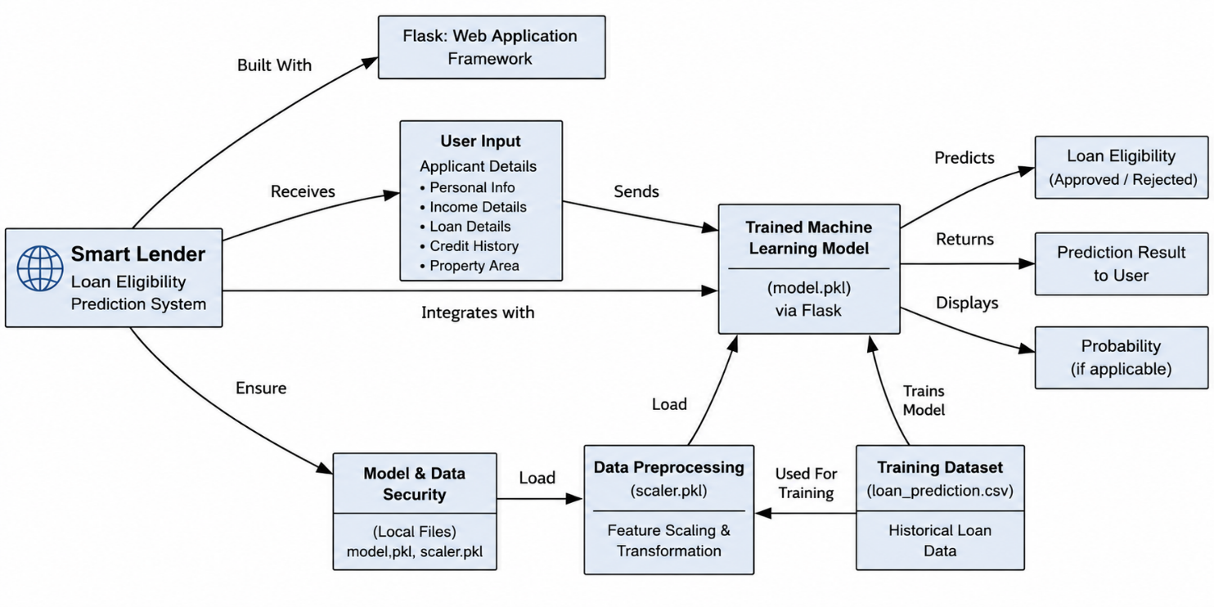
Description
Smart Lender follows a modular three-layer architecture consisting of the Presentation Layer, Application Layer, Machine Learning Layer, and Data Layer.
- The Presentation Layer provides a user-friendly web interface developed using HTML, CSS, and JavaScript.
- The Application Layer is developed using the Flask framework, which handles routing, user requests, validation, and communication with the machine learning model.
- The Machine Learning Layer preprocesses applicant information and predicts loan eligibility using the trained model.
- The Data Layer stores the training dataset, trained machine learning model (model.pkl), and preprocessing scaler (scaler.pkl).
This architecture ensures modularity, maintainability, and scalability for future enhancements.

Pre-requisites:
Before implementing Smart Lender, the following knowledge and tools are recommended:
- Python Programming
- Machine Learning Fundamentals
- Flask Framework
- HTML, CSS, and JavaScript
- Pandas and NumPy
- Scikit-learn
- Jupyter Notebook
- Visual Studio Code
- Git and GitHub
- Basic understanding of loan approval datasets and data preprocessing

Project Workflow:

Milestone 1: Dataset Collection & Model Selection

Activity 1.1: Collect the Loan Dataset
- Download a publicly available loan eligibility dataset.
- Verify the dataset contains all required applicant attributes.
- Store the dataset in CSV format for preprocessing.

Activity 1.2: Analyze the Dataset
- Study all input and output features.
- Identify missing values and data types.
- Understand the relationship between applicant details and loan approval.

Activity 1.3: Select the Machine Learning Algorithm
- Compare suitable classification algorithms.
- Train multiple models such as Decision Tree, Random Forest, KNN, and XGBoost.
- Select the model with the best prediction accuracy.

Activity 1.4: Set Up the Development Environment
- Install Python and required libraries.
- Install Flask.
- Install Scikit-learn, Pandas, NumPy, Joblib, and Matplotlib.
- Configure Visual Studio Code and Jupyter Notebook.

Milestone 2: Data Preprocessing & Model Development

Activity 2.1: Data Cleaning
- Handle missing values.
- Remove duplicate records.
- Convert categorical variables into numerical values.

Activity 2.2: Feature Engineering
- Select important features affecting loan approval.
- Apply feature encoding.
- Perform feature scaling using StandardScaler.

Activity 2.3: Model Training
- Split the dataset into training and testing datasets.
- Train multiple machine learning models.
- Compare model performance.

Activity 2.4: Model Evaluation
- Evaluate models using Accuracy Score.
- Select the best-performing model.
- Save the trained model as model.pkl.
- Save the scaler as scaler.pkl.

Milestone 3: Flask Application Development

Activity 3.1: Create the Flask Application
- Develop the Flask backend.
- Configure application routes.
- Integrate HTML templates.

Activity 3.2: Integrate Machine Learning Model
- Load model.pkl.
- Load scaler.pkl.
- Accept user input.
- Preprocess the input.
- Predict loan eligibility.

Activity 3.3: Display Prediction Results
- Return prediction results to the frontend.
- Display whether the loan is Approved or Rejected.

Milestone 4: Frontend Development

Activity 4.1: Design User Interface
- Develop responsive HTML pages.
- Apply CSS styling.
- Add JavaScript for user interaction.

Activity 4.2: Build Input Forms
- Create a loan application form.
- Collect applicant information.
- Validate input before submission.

Activity 4.3: Display Results
- Show prediction results on a dedicated page.
- Display approval or rejection status.
- Improve user experience with a clean interface.

Milestone 5: Testing & Deployment

Activity 5.1: Functional Testing
- Verify user input functionality.
- Test prediction accuracy.
- Validate application workflow.

Activity 5.2: Local Deployment
- Install dependencies using:
pip install -r requirements.txt
- Run the application:
python app.py
- Access the application at:
http://127.0.0.1:5000

Activity 5.3: GitHub Repository
- Upload the complete project to GitHub.
- Maintain project documentation.
- Verify all project files are available in the repository.

Milestone 6: Conclusion
The Smart Lender project successfully demonstrates the application of Machine Learning in predicting loan eligibility. By integrating a trained classification model with a Flask web application, the system provides quick and reliable loan approval predictions based on applicant information. The project reduces manual evaluation effort, improves consistency in decision-making, and provides a user-friendly interface for loan prediction. The modular architecture allows future enhancements such as cloud deployment, database integration, user authentication, and improved machine learning models to further increase the system's capabilities.

Milestone 1: Dataset Collection & Model Selection
Milestone 1 focuses on collecting a suitable loan eligibility dataset, understanding its structure, selecting the most appropriate machine learning algorithm, and preparing the development environment for implementation.

Activity 1.1: Collect the Loan Eligibility Dataset
Before developing the prediction system, a suitable dataset containing historical loan application records is required.

Step 1 – Obtain the Dataset
- Download the Loan Eligibility Prediction dataset from a reliable public source such as Kaggle.
- Store the dataset in CSV format.

Step 2 – Verify Dataset Features
Ensure the dataset contains the following attributes:
- Gender
- Married
- Dependents
- Education
- Self Employed
- Applicant Income
- Coapplicant Income
- Loan Amount
- Loan Amount Term
- Credit History
- Property Area
- Loan Status

Step 3 – Store the Dataset
Save the dataset inside the project directory.
dataset/
loan_prediction.csv
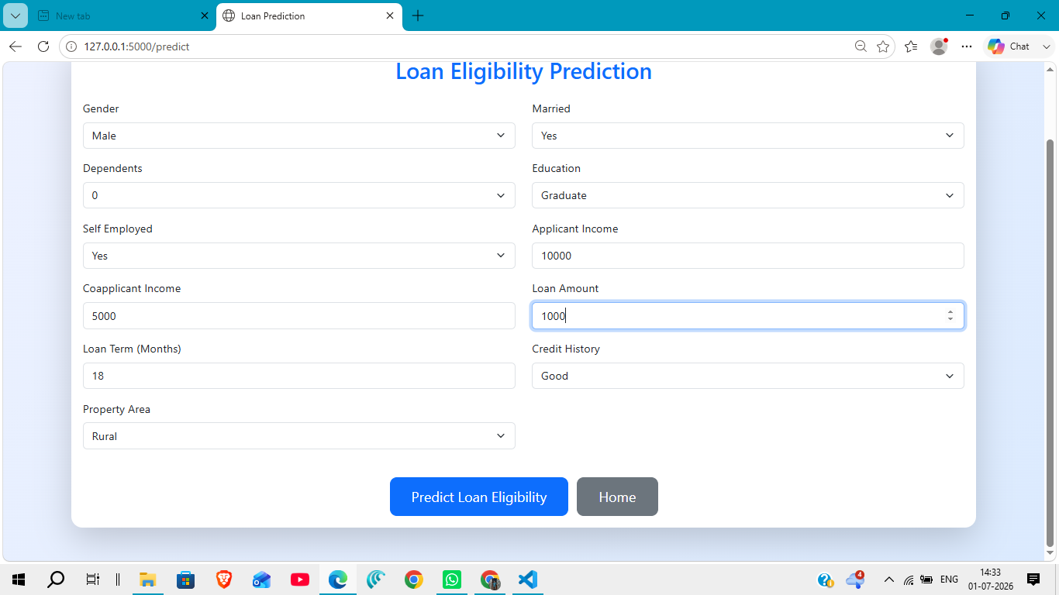

Activity 1.2: Analyze the Dataset
Before training the model, understand the dataset characteristics.

Study the Dataset
- Identify the number of records and attributes.
- Check data types.
- Detect missing values.
- Analyze categorical and numerical features.

Perform Exploratory Data Analysis
- Observe the relationship between applicant income and loan approval.
- Analyze the impact of credit history.
- Study loan amount distribution.
- Visualize important features using graphs.
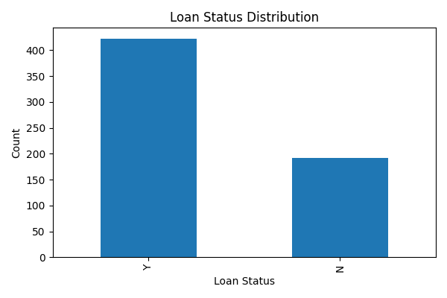
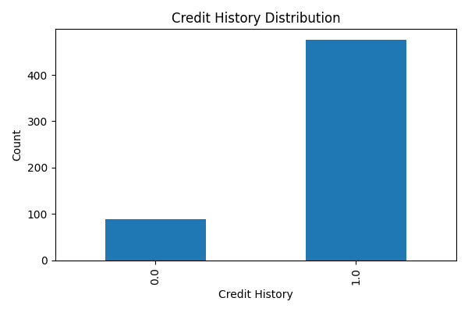
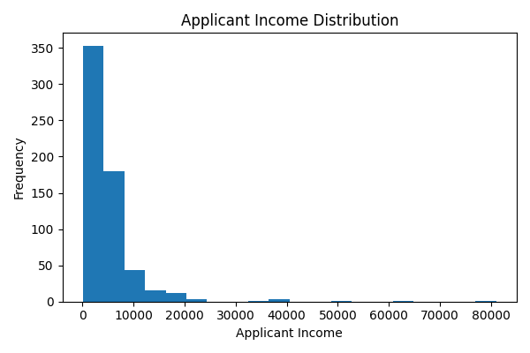

Activity 1.3: Select the Machine Learning Model
Several classification algorithms were evaluated to determine the best-performing model.

Candidate Models
- Decision Tree Classifier
- Random Forest Classifier
- K-Nearest Neighbors (KNN)
- XGBoost Classifier

Model Evaluation
The models were compared using prediction accuracy.
The best-performing model was selected and saved for deployment.
model.pkl
The preprocessing scaler was also saved.
scaler.pkl
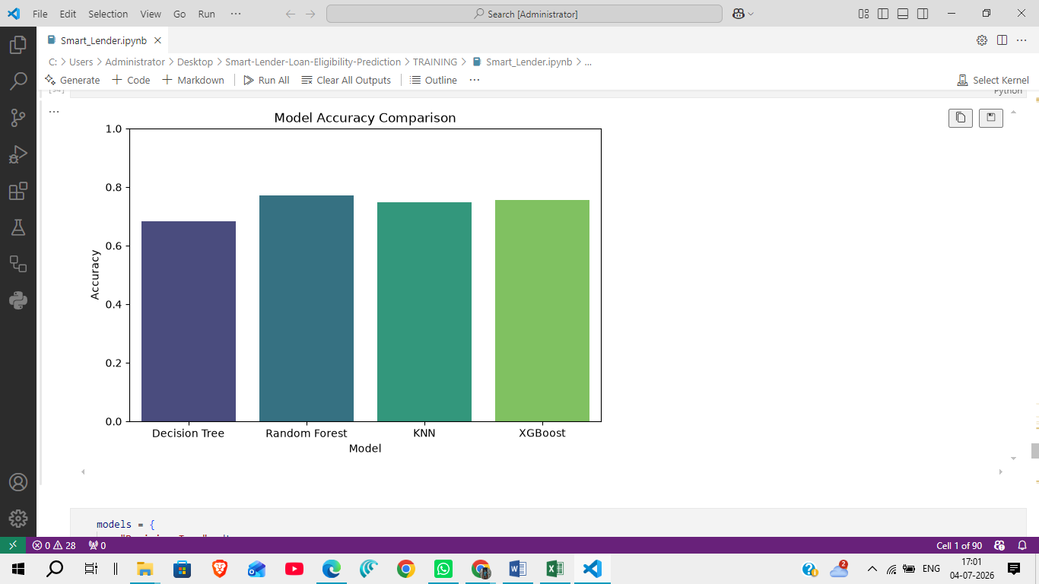

Activity 1.4: Set Up the Development Environment

Install Python
Install Python 3.10 or later.

Create a Virtual Environment
python -m venv venv
Activate it.
Windows
venv\Scripts\activate

Install Required Libraries
pip install -r requirements.txt

Required Libraries
- Flask
- Pandas
- NumPy
- Scikit-learn
- Joblib

Development Tools
- Visual Studio Code
- Jupyter Notebook
- Git
- GitHub

Project Folder Structure
Smart-Lender-Loan-Eligibility-Prediction/
│── TRAINING/
│── dataset/
│── flask/
│── screenshots/
│── README.md
│── requirements.txt

Milestone 2: Data Preprocessing & Model Development
Milestone 2 focuses on preparing the dataset for machine learning, transforming raw data into a suitable format, training different classification models, evaluating their performance, and selecting the best model for deployment.

Activity 2.1: Data Preprocessing
The collected loan dataset contains both numerical and categorical features. Before model training, preprocessing is performed to improve data quality and model performance.

Step 1: Handle Missing Values
- Identify missing values in the dataset.
- Replace missing numerical values using appropriate statistical methods.
- Replace missing categorical values with the most frequent category.

Step 2: Encode Categorical Features
Convert categorical attributes into numerical values.
Example attributes include:
- Gender
- Married
- Education
- Self Employed
- Property Area
- Loan Status

Step 3: Feature Scaling
Apply feature scaling to numerical attributes using StandardScaler.
Scaled features include:
- Applicant Income
- Coapplicant Income
- Loan Amount
- Loan Amount Term
The fitted scaler is saved as:
scaler.pkl
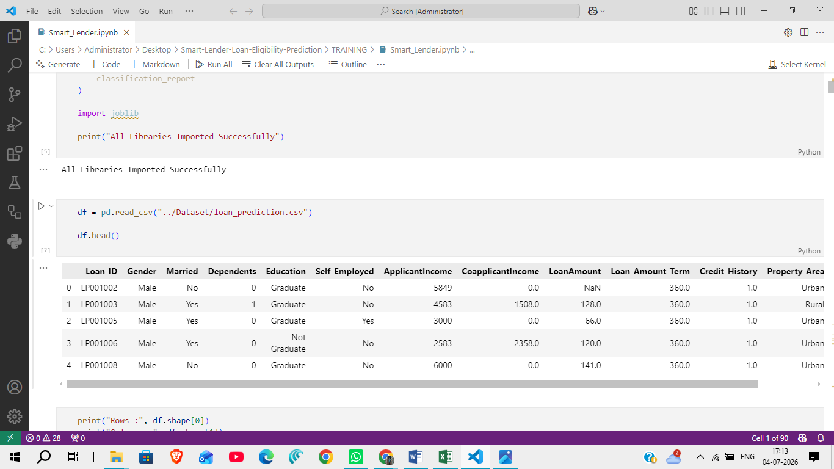

Activity 2.2: Feature Selection
Relevant applicant information is selected for prediction.

Selected Features
- Gender
- Married
- Dependents
- Education
- Self Employed
- Applicant Income
- Coapplicant Income
- Loan Amount
- Loan Amount Term
- Credit History
- Property Area

Target Variable
Loan Status

Activity 2.3: Model Training
Different machine learning classification algorithms are trained using the processed dataset.

Models Used

Decision Tree Classifier
- Simple tree-based classification model.
- Easy to understand and implement.

Random Forest Classifier
- Ensemble learning algorithm.
- Reduces overfitting.
- Provides improved prediction accuracy.

K-Nearest Neighbors (KNN)
- Classifies applicants based on similarity with neighboring records.
- Simple and effective for classification problems.

XGBoost Classifier
- Gradient boosting algorithm.
- Produces high prediction accuracy.
- Selected as the final prediction model for deployment. 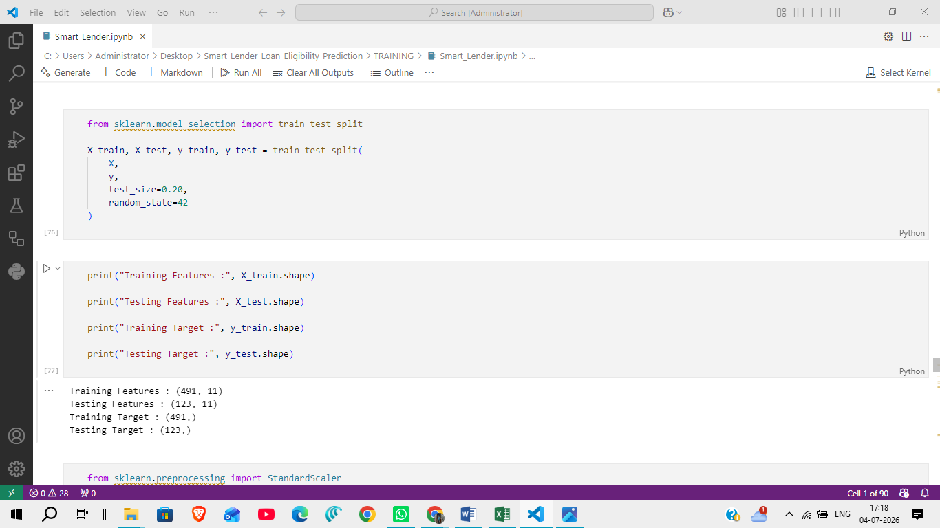

Activity 2.4: Model Evaluation
Each trained model is evaluated using the testing dataset.

Evaluation Metrics
- Accuracy Score
- Confusion Matrix
- Classification Report
The model with the highest prediction accuracy is selected.

Activity 2.5: Save the Trained Model
The selected machine learning model is stored for deployment.

Saved Files
model.pkl
scaler.pkl
These files are loaded by the Flask application to perform real-time loan eligibility prediction.

Activity 2.6: Verify Prediction
Sample applicant records are tested before deployment.

Sample Test Input
Feature | Value
Gender | Male
Married | Yes
Education | Graduate
Self Employed | No
Applicant Income | 5000
Coapplicant Income | 2000
Loan Amount | 150
Loan Amount Term | 360
Credit History | 1
Property Area | Urban

Prediction Output
Loan Status : Approved

Milestone 3: Flask Application Development
Milestone 3 focuses on developing the backend web application using the Flask framework. The Flask application acts as the bridge between the user interface and the trained machine learning model. It receives applicant information, preprocesses the input, loads the trained model, generates predictions, and returns the result to the user.

Activity 3.1: Create the Flask Application
The Flask framework is used to build the backend of the Smart Lender application. It manages routing, request handling, and communication between the frontend and the machine learning model.

Step 1: Create the Flask Project Structure
Organize the project into folders for templates, static files, models, and application logic.
flask/
│── app.py
│── model.pkl
│── scaler.pkl
│
├── templates/
│ ├── index.html
│ ├── predict.html
│ ├── result.html
│ └── about.html
│
└── static/
├── css/
│ └── style.css
├── js/
│ └── script.js
└── images/

Step 2: Initialize the Flask Application
- Import the Flask library.
- Create the Flask application object.
- Configure routes for different web pages.
Main routes include:
- Home Page
- Prediction Page
- Result Page
- About Page

Activity 3.2: Integrate the Machine Learning Model
The trained machine learning model is integrated into the Flask application to provide real-time predictions.

Step 1: Load the Saved Model
Load the trained model.
model.pkl
Load the preprocessing scaler.
scaler.pkl

Step 2: Receive User Input
The application receives the following details from the prediction form:
- Gender
- Married
- Dependents
- Education
- Self Employed
- Applicant Income
- Coapplicant Income
- Loan Amount
- Loan Amount Term
- Credit History
- Property Area

Step 3: Preprocess Input Data
Before prediction:
- Convert categorical values into numerical format.
- Scale numerical values using the saved scaler.
- Arrange the features in the required order.

Step 4: Generate Prediction
The processed data is passed to the trained machine learning model.
The model predicts one of the following outcomes:
- Loan Approved
- Loan Rejected

Activity 3.3: Display Prediction Result
After prediction, the Flask application sends the result back to the web interface.
The Result page displays:
- Applicant Details
- Loan Eligibility Status
- Approval or Rejection Message

Activity 3.4: Input Validation
To improve reliability, the application validates user input before prediction.
Validation includes:
- Required fields must not be empty.
- Numerical fields must contain valid numbers.
- Loan amount must be greater than zero.
- Credit History must contain valid values.
- Invalid data is rejected before prediction.

Activity 3.5: Error Handling
Basic exception handling is implemented to prevent application failure.
Examples include:
- Invalid input values.
- Missing model files.
- Prediction errors.
- Incorrect form submission.
If an error occurs, the application displays an appropriate error message instead of crashing.

Activity 3.6: Application Workflow
The overall workflow of the Flask application is as follows:
User Opens Website
│
▼
Enter Applicant Details
│
▼
Submit Prediction Request
│
▼
Flask Receives Request
│
▼
Input Validation
│
▼
Data Preprocessing
│
▼
Load model.pkl & scaler.pkl
│
▼
Machine Learning Prediction
│
▼
Return Loan Status
│
▼
Display Result Page

Milestone 4: Frontend Development
Milestone 4 focuses on designing and developing a user-friendly web interface for the Smart Lender application. The frontend enables users to enter applicant details, submit loan eligibility requests, and view prediction results through a responsive and intuitive interface.

Activity 4.1: Design and Develop the User Interface
The frontend is developed using HTML5, CSS3, and JavaScript to provide a responsive and interactive web experience.

Step 1: Create HTML Pages
The application consists of the following pages:
- Home Page (index.html) – Introduces the Smart Lender application.
- Prediction Page (predict.html) – Allows users to enter applicant details.
- Result Page (result.html) – Displays the loan eligibility prediction.
- About Page (about.html) – Provides project information.
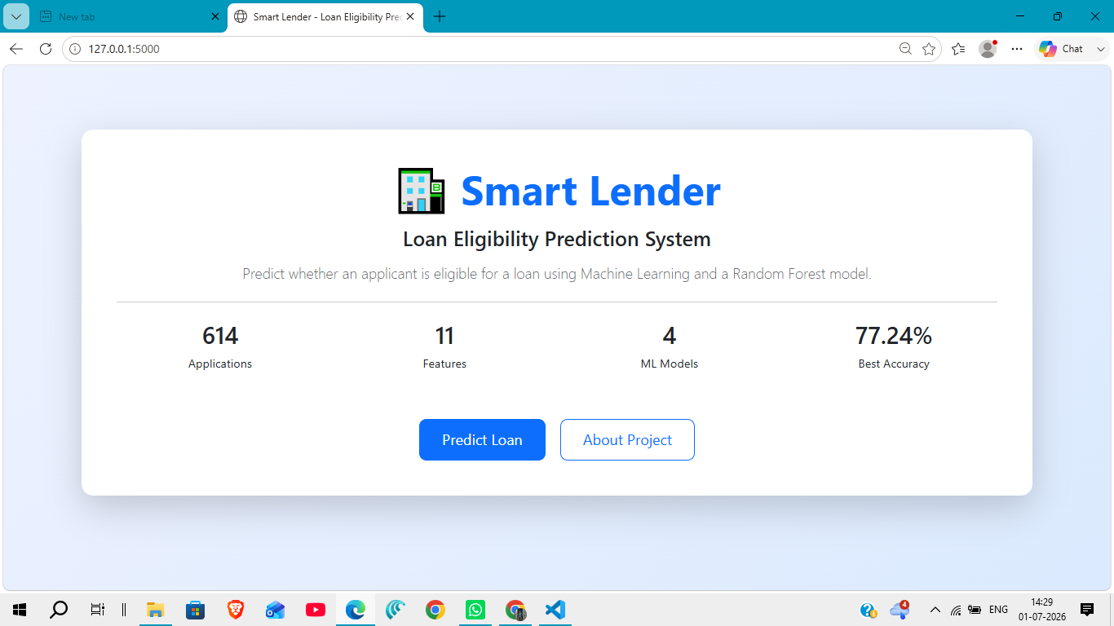

Step 2: Design the User Interface
- Create a clean and responsive layout.
- Use navigation menus for easy access to different pages.
- Organize input fields in a structured form.
- Display prediction results in an easy-to-read format.

Activity 4.2: Develop the Loan Prediction Form
The prediction form is designed to collect all necessary applicant information required by the machine learning model.

Input Fields
- Gender
- Married
- Dependents
- Education
- Self Employed
- Applicant Income
- Coapplicant Income
- Loan Amount
- Loan Amount Term
- Credit History
- Property Area

Form Features
- Required field validation.
- Drop-down menus for categorical inputs.
- Numeric validation for income and loan amount.
- Predict button to submit the application.


Activity 4.3: Apply CSS Styling
The application uses CSS3 to improve appearance and usability.

UI Enhancements
- Responsive layout for desktop and mobile devices.
- Consistent color scheme and typography.
- Styled input fields and buttons.
- Card-based layout for prediction results.
- Proper spacing and alignment for readability.

Activity 4.4: Implement JavaScript Functionality
JavaScript is used to enhance user interaction.

Features
- Client-side input validation.
- Interactive form behavior.
- Smooth navigation between pages.
- Improved user experience during form submission.

Activity 4.5: Display Prediction Results
After processing the applicant information, the prediction result is displayed on the Result page.

Output Includes
- Loan Approval Status (Approved / Rejected)
- Clear prediction message.
- Option to return and submit another prediction.
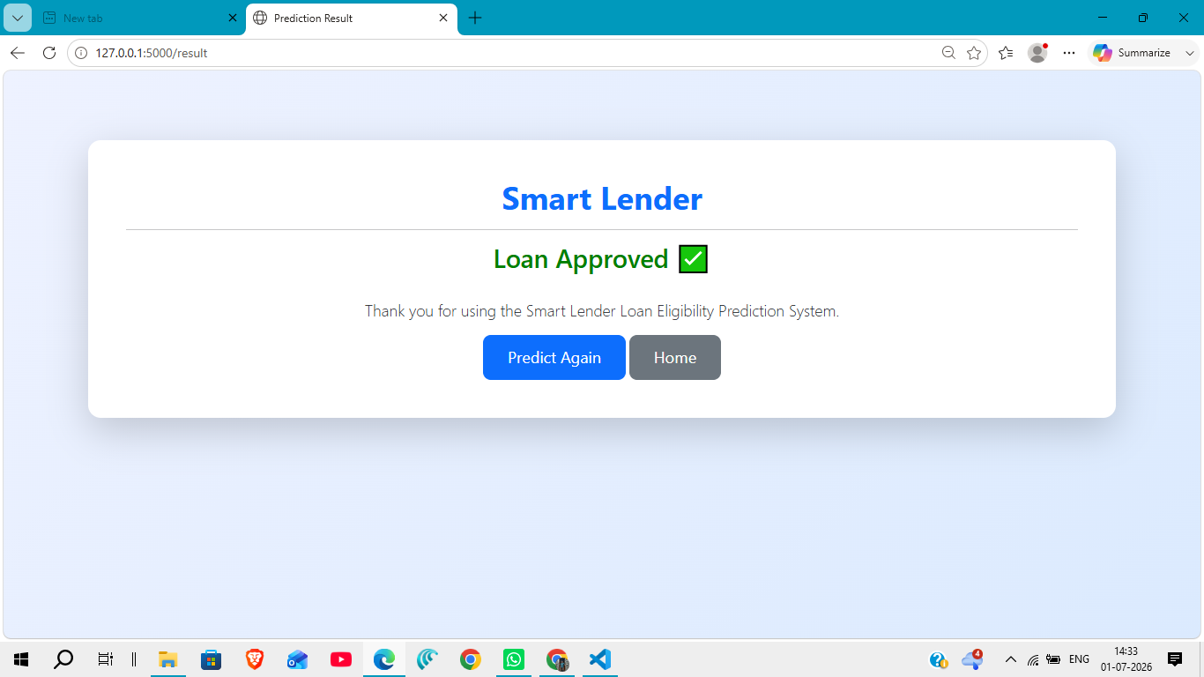

Activity 4.6: Frontend Navigation
The application includes easy navigation between pages.

Navigation Flow
Home Page
│
▼
Prediction Page
│
▼
Enter Applicant Details
│
▼
Click Predict
│
▼
Result Page
│
▼
Return to Home / Predict Again

Activity 4.7: User Experience Improvements
To improve usability, the following features are included:
- Simple and intuitive interface.
- Responsive design for different screen sizes.
- Clear labels for all input fields.
- Immediate display of prediction results.
- Easy navigation between pages.

Activity 4.8: Frontend Technologies Used
Technology | Purpose
HTML5 | Structure of the web pages
CSS3 | Styling and responsive design
JavaScript | Client-side interaction and validation
Flask Templates | Dynamic page rendering

Milestone 5: Testing & Deployment
Milestone 5 focuses on verifying the functionality of the Smart Lender application, ensuring accurate loan eligibility predictions, validating the user interface, and preparing the project for local deployment and GitHub submission.

Activity 5.1: Prepare the Application for Local Deployment

Install Python
Ensure Python 3.10 or later is installed on your system.

Create a Virtual Environment
Open Command Prompt and execute:
python -m venv venv
Activate the virtual environment.
Windows
venv\Scripts\activate

Install Required Dependencies
Navigate to the project folder and install all required libraries.
pip install -r requirements.txt
The required libraries include:
- Flask
- Pandas
- NumPy
- Scikit-learn
- Joblib

Activity 5.2: Local Testing and Verification

Start the Flask Server
Run the application.
python app.py
The Flask server starts successfully.

Access the Application
Open a web browser and navigate to:
http://127.0.0.1:5000

Verify the Application
Perform the following tests:
- Open the Home Page.
- Navigate to the Prediction Page.
- Enter valid applicant details.
- Submit the prediction request.
- Verify that the prediction result is displayed correctly.
- Test invalid or incomplete input and verify validation messages.

Activity 5.3: Functional Testing
The following functional tests were performed.
Test Case | Expected Result | Status
Home page loads successfully | Display homepage | Pass
Prediction page opens | Display prediction form | Pass
Valid applicant data submitted | Loan prediction generated | Pass
Invalid input submitted | Validation message displayed | Pass
Result page displays prediction | Approved/Rejected shown | Pass

Activity 5.4: Performance Verification
The application was tested on a local Flask server.

Performance Metrics
- Average response time: Less than 2 seconds.
- Prediction generated successfully.
- No critical runtime errors observed.
- Stable application performance during testing.

Activity 5.5: GitHub Repository
The completed project was uploaded to GitHub for version control and documentation.
Repository Link
https://github.com/CHANDRASAI9491/Smart-Lender-Loan-Eligibility-Prediction

Activity 5.6: Project Screenshots
The following screenshots were captured during testing.
- Home Page
- Prediction Page
- Loan Approved Result
- Loan Rejected Result
- About Page
These screenshots are available in the screenshots folder of the repository.

Activity 5.7: Deployment Status
Current Deployment
- Local Flask Development Server
Future Deployment Options
- Render
- Railway
- IBM Cloud
- Microsoft Azure
- AWS

Activity 5.8: Final Verification Checklist
✔ Flask application starts successfully.
✔ Machine learning model loads correctly.
✔ User input is validated.
✔ Loan eligibility prediction is generated.
✔ Prediction result is displayed correctly.
✔ Project documentation is completed.
✔ Source code uploaded to GitHub.

Milestone 6: Conclusion
The Smart Lender – Loan Eligibility Prediction Using Machine Learning project successfully demonstrates the use of Machine Learning and Flask to automate loan eligibility prediction. By analyzing applicant information such as income, education, credit history, and loan amount, the system provides quick and reliable predictions that support informed decision-making.
The project integrates data preprocessing, machine learning model training, and a user-friendly web interface into a single application. This reduces manual effort, improves consistency, and enables faster loan evaluation compared to traditional methods.
The modular architecture and organized project structure make the application easy to maintain and extend. Future enhancements may include cloud deployment, database integration, user authentication, explainable AI techniques, and support for additional financial parameters.
Overall, the Smart Lender project demonstrates the practical application of machine learning in the banking and financial domain while providing a scalable foundation for future development.

